**CIMI Agenda and Minutes**

**May 19, 2016**

**Co-Chairs:**

* **Linda Bird BIT PhD,** IHTSDO, [lbi@ihtsdo.org](mailto:lbi@ihtsdo.org)
* **Galen Mulrooney MBA,** U.S. Department of Veterans Affairs, Phone: USA +1 703-815-0900, [galen.mulrooney@jpsys.com](mailto:galen.mulrooney@jpsys.com)
* **Harold Solbrig,** Mayo Clinic, [solbrig.harold@mayo.edu](mailto:solbrig.harold@mayo.edu)
* **Stanley Huff MD,** Intermountain Healthcare, Phone: USA +1 801-507-9111  
  [stan.huff@imail.org](mailto:stan.huff@imail.org)

  The “CIMI Practitioners Guide to HIE Interoperability” is being developed by the CIMI workgroup. This document is typically versioned each Monday to incorporate the previous Thursday’s CIMI WG telecom technical discussions.  The current MS Word version is always available at: <http://1drv.ms/1TuV8PD>

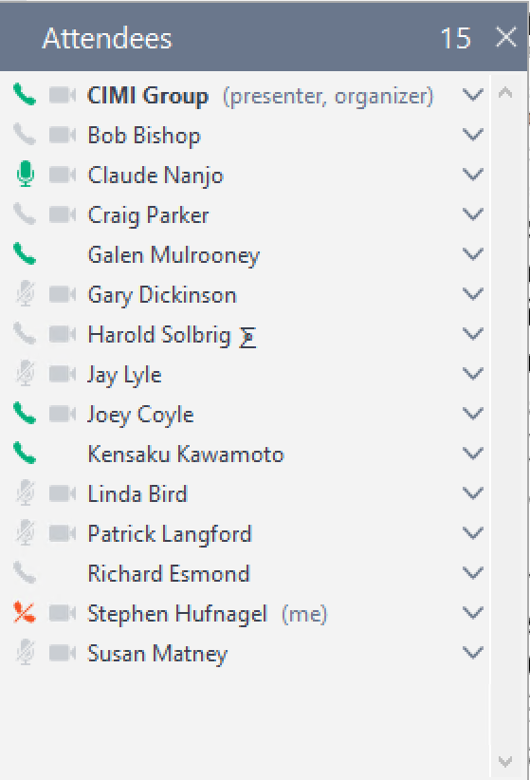

**Telecom:** Thursday US time, Friday Australia will be at 20:00 UTC.

<https://global.gotomeeting.com/join/754419973>  
  
**You can also dial in using your phone.**

United States : +1 (224) 501-3316  
Access Code: 754-419-973

**More phone numbers**

Australia : +61 2 8355 1034  
Belgium : +32 (0) 28 93 7002  
Canada : +1 (647) 497-9372  
Denmark : +45 89 88 03 61  
Netherlands : +31 (0) 208 084 055  
New Zealand : +64 4 974 7243  
Spain : +34 932 20 0506  
Sweden : +46 (0) 853 527 818  
United Kingdom : +44 (0) 330 221 0098

Annotated Agenda:

* Agenda review
* Subsequent meetings:
  + Standing item for status updates on projects
  + Informal sharing on ADL and other topics for 20-30 minutes
* Montreal follow-up
  + I could use help with the minutes from the Montreal sessions
    - Please forward minutes or notes from any of the sessions
  + FHIM – CIMI Task Force
    - Steve Hufnagel, Jay Lyle, Claude Nanjo, Linda Bird, Bob Bishop, Stan Huff, Galen Mulrooney, Richard Esmond
    - Stan to set up one or more meetings to make a first draft of a plan that addresses the issues discussed on a previous call
      * Claude will send out a poll for a good time
  + Modeling of skin and wound assessments with PC
    - CEM to ADL – from Joey
    - Requirements to ADL from Jay
    - Compare
  + We (Stan) need to find resources to evaluate the feasibility of using FHIR Structure Definitions to represent logical computer models, the capabilities of the ADL AOM (and/or AML AOM).
    - Harold would like to work on this
    - Richard – they are working on things similar to this right now
  + Also use of mapping language to get from an archetype to a FHIR profile. Planning to do for CQI. The scope is the set of archetypes including procedure proposal and 3-4 other archetypes for the Baltimore meeting.
  + Experiment from Grahame – mapping of existing archetype to a “logical model” using Structured Definitions and then over FHIR Resource and then to a FHIR profile
    - Harold is interested in participating if we can find funding
    - Linda is tracking this work also
  + CIMI is an interested party for the negation project.
    - Requirements from Linda and IHTSDO - 7.8.2.4.7 Retrieving absent findings
  + Insight (Stan): The key value of CIMI is creating content. We need to find simple ways to capture logical model content while we continue to work on formal syntactical representations and transformations
  + Gary – functional models for EHR, specification of data requirements, inputs and outputs, use of the FHIM as the basis for data statements
  + Other actions? - All
* FHIR proposed Vital Signs panel
  + see <http://argonautwiki.hl7.org/index.php?title=Vital_Signs>
  + The panel is very basic. I looks correct, except for the panel LOINC code (8716-3) which should be a NOM code instead of a NAR.
  + Stan to let Grahame know.
* Proposal: Extend the call to two hours, one hour for clinical content, and one hour for policy and technical and relationship and process issues. Approved by consensus.
* Continued work on the preferred model for Conditions/Problems/Health Issues – Stan
* Future topics
  + How CIMI extension use integrates with national releases
  + The role of openEHR-like templating in CIMI’s processes - Stan
  + Model approval process
    - What models do we want to ballot?
  + IHTSDO work for binding SNOMED CT to FHIR resources – Linda, Harold
  + Which openEHR archetypes should we consider converting to CIMI models?
  + Model transformations
  + Semantic terminology bindings at the level of the whole model
    - Is it correct to bind “id” nodes to terminologies without going through an “at” node?
    - Test code should be bound to LOINC; should the root also?
  + Transform of ICD-10 CM to CIMI models – Richard
  + Others?
* Any other business